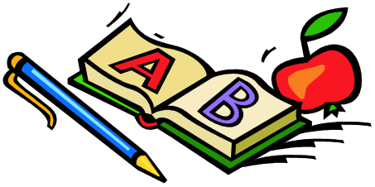
School Supplies

Dear Parents,
Many of you have asked what supplies could help your child in the classroom. Here is a list of items we will use throughout the year. With all of our budget cuts, any of these items would be greatly appreciated!

- Ear phones for iPod/Computer
- Pencil Box
- 3 holed notebook paper
- Highlighters: yellow, blue, green
- Red fine point pen
- 1 set of Crayola Twistable Colored Pencils and Crayola Twistable Crayons OR 1 pack of colored pencils. The thing that is cool about the Twistables is that they don’t break and don’t need sharpening. Can be bought online too at Shoplet.com or other sites

- 1 pack of 24 crayons (These are needed for special art projects even though you purchase the Twistables)

- Ticonderoga pencils (These are quality lead pencils. They sharpen evenly, don’t split, and the pencil is still useable after it is sharpened)

- 2 dry erase markers to be used on a white board

- Mr. Clean Magic Easers

- A Pad of Multi- Colored (4by4) Sticky Notes

- Pink pearl eraser (regular size eraser)

- Ruler
- Small pencil sharpener

- Glue bottle and glue stick

- Box of Kleenex
- Tub of Wet Ones
Thank You!! 

